**Tasks**

**Objective Questions:**

1. What is the total no. of tables present in the data?

**Answer - The total number of tables are 2**

**1.Raw data**

**2. country description**

2.What is the total no. of attributes present in the data?

**Answer - The total number of attributes is 20 in raw data and 6 in Country description**

3. How many categorical columns are there in the data?

**Answer -** 14 categorical columns present.

**In Raw Data 14 columns**

1. **Restaurant Name**
2. **Country Code**
3. **City**
4. **Address**
5. **Locality**
6. **Locality Verbose**
7. **Cuisines**
8. **Currency**
9. **Has Table booking**
10. **Has Online delivery**
11. **Is delivering now**
12. **Switch to order menu**
13. **Price range**
14. **Rating**

**In Country description 4 columns**

1. **Country Code**
2. **Country Name**
3. **Currency**
4. **Currency Symbol**

4. The data consists of some inconsistent and missing values so ensure that the dataused for further analysis is cleaned.

**Answer -Identifying the duplicates in the raw data.**

**Used Excel's built-in feature for identifying duplicates. Select the column(s) where duplicates exist, then go to the "Data" tab, and click on "Remove Duplicates". No Duplicates are present here.**

**Then**

**Search for missing values: -**

**Find missing values in the cuisines row by usind excel filter method, replace that missing values by doing mode.**

**Replaced special character “í©” with “e”.**

**Removed any occurrence of “#”**

**Removed special character “±”.**

**Formula: =IF($S2=0,AVERAGEIFS($S:$S,$C:$C,$C2,$D:$D,$D2),$S2)**

* + - **S2=0 Check if cost is 0.**
    - **AVERAGEIFS($S:$S,$C:$C,$C2,$D:$D,$D2) If true take average of that city.**
    - **$S2 false condition**

1. Using the LookUp functions, fill up the countries in the original data using thecountry code.

**Answer - lookup function**

**Formula: =LOOKUP(C2,'country description'!$A$2:$A$16,'country description'!$B$2:$B$16)**

6. Create a table to represent the number of restaurants opened in each country.

**Answer -** - **To find the ans I used a pivot table to demonstrate the count of restaurant according to the country name**

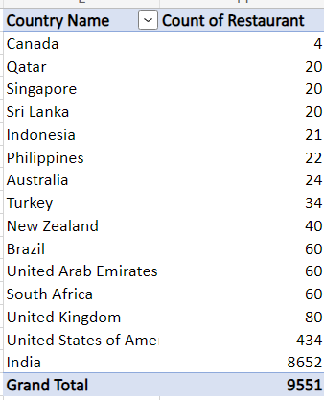

7. Also, the management wants to look at the number of restaurants opened each year, so provide them with something here.

**Answer - The number of restaurants opened in each year created pivot table**

**In the Excel sheet named “KP1(Count of Restaurant)”**

**the pivot table that displays the number of restaurants opened in each year.**

8. What is the total number of restaurants in India in the price range of 4?

**Answer - In India the total number of restaurants in the price range of 4 is 388**

**In the Excel sheet named “KP1(Count of Restaurant)”**

**the pivot table that displays the total number of restaurants in the price range of 4.**

9. What is the average number of voters for the restaurants in each country according to the data?

**Answer –**

|  |  |
| --- | --- |
| Country | Average of Votes |
| Australia | 111.4166667 |
| Brazil | 19.61666667 |
| Canada | 103 |
| India | 137.212552 |
| Indonesia | 772.0952381 |
| New Zealand | 243.025 |
| Philippines | 407.4090909 |
| Qatar | 163.8 |
| Singapore | 31.9 |
| South Africa | 315.1666667 |
| Sri Lanka | 146.45 |
| Turkey | 431.4705882 |
| United Arab Emirates | 493.5166667 |
| United Kingdom | 205.4875 |
| United States of America | 428.2211982 |

10. Calculate the average rating for all the restaurants that have price_range< 4 and provide online delivery. Use only the “IF” function, Logical Operators, and Aggregation functions to solve this problem.

**Answer - The average rating for all the restaurants that have price_range< 4 and provide online delivery is 3.2**

**Formula: =AVERAGEIFS('Modified Data'!U:U, 'Modified Data'!Q:Q, "<4", 'Modified Data'!N:N, "Yes")**

11. Using Conditional formatting highlight the rows of restaurants that are located in the countries or cities that you’ve suggested to the management for opening new restaurants.

**Answer - we’ve discovered that 59 cities within the dataset have fewer than 10 restaurants. This finding presents a strategic opportunity for management: consider opening new restaurants in these specific locations. By doing so, they can potentially tap into underserved markets and significantly expand the business’s reach.**

**For conditional formatting –**

**Select Data**

**Conditional Formatting**

**Formula:**

**Use the following formula: =COUNTIF($D$2:$D$9551,$D2)<10.**

**Format Colour:**

12. Create a new customized price column that consists of the abbreviation/symbol of the cur

**Answer -**

**Formula: =CONCATENATE(VLOOKUP('Modified Data'!$C2,'country description'!$A$2:$D$16,4,0),$S2)**

**Reference - In the Excel sheet named “Modified Data”, the column is labelled as “X”.**

13. How can you create an array formula in Excel or Google Sheets to count the number of restaurants listed that do not offer online delivery, are in the lowest price range, and have an average cost for two people less than or equal to 250 Indian Rupees?

**Answer - The count of the number of restaurants listed that do not offer online delivery, are in the lowest price range, and have an average cost for two people less than or equal to 250 Indian Rupees is 1685.**

**Formula: =COUNTIFS('Modified Data'!$N:$N,"No",'Modified Data'!$Q:$Q,1,'Modified Data'!$S:$S,"<=250",'Modified Data'!$L:$L,"Indian Rupees(Rs.)")**

**Reference - In the Excel sheet named “KPI3_Calculations”.**

**Subjective Question:**

1. Suggest a few countries where the team can open newer restaurants with lesser competition. Which visualization/technique will you use here to justify the suggestions?

**Countries Recommended for New Restaurants:**

* **Australia**
* **Canada**
* **Singapore**
* **Sri Lanka**

**Visualization Style:**

**Reference - In the Excel sheet named “Suggestions”**

**the pivot table that Suggesting few countries where the team can open newer restaurants with lesser competition.**

2. Come up with the names of States and cities in the suggested countries suitable for opening restaurants.

**Answer -**

**Cities Recommended for New Restaurants:**

**Australia:**

* + **Armida**
  + **Inverloch**
  + **Lakes Entrance**
  + **Lorn**
  + **Penola**
  + **Phillip Island**
  + **Tanunda**
  + **Trentham East**
  + **Victor Harbor**

**Canada:**

* + **Chatham**
  + **Consort**
  + **Vineland Station**
  + **Yorkton**

**Reference - In the Excel sheet named “Suggestions”**

**the pivot table that Suggesting the names of States or cities in the countries suitable for opening restaurants.**

3. According to the countries you suggested, what is the current quality regarding ratings for restaurants that are open there?

**Answer –**

|  |  |
| --- | --- |
| Average rating for selected Country | |
| Country | Ratings |
| Canada | 3.575 |
| Singapore | 3.575 |
| Sri Lanka | 3.87 |
| Australia | 3.658333333 |

**Data Exploration Approach:**

* **I generated a new table called “Average Rating for Selected Country”.**
* **The values in this table were extracted from the “New Restaurant Suggestion” pivot table.**

4. Also, what is the current expenditure on food in the suggested countries, so we can keep our financial expenditure in control?

**Answer -Data Exploration Approach:**

**I created a new table called “Expenditure on Food in Suggested Country”.**

**The values in this table were calculated using the SUMIF formula.**

**Currency Conversion:**

**I converted the expenditure to USD based on the current exchange rate.**

**Formula: =SUMIF('Modified Data'!$E:$E,"Canada",'Modified Data'!$S:$S)*'country description'!$H$3**

**Formula Explanation:**

**SUMIF('Modified Data'!$E:$E,"Canada",'Modified Data'!$S:$S):**

|  |  |
| --- | --- |
| Expenditure on food in suggested country | |
| Country | Expenditure |
| Canada | $107.30 |
| Singapore | $2,305.10 |
| Sri Lanka | $152.00 |
| Australia | $375.70 |

5. Come up with the names of restaurants from the recommended states that are our biggest competitors and also those that are rated in the lower brackets, i.e. 1-2 or 2-3.

**Answer –**

**Data Exploration Approach:**

* **I employed a comprehensive approach using four distinct pivot tables, each focusing on a specific country.**
* **The row section includes both the Country and Restaurant Name, and I calculated the average ratings.**
* **This analysis enables a thorough evaluation of competitors based on their ratings.**
* **Competitor Evaluation Criteria:**
* **Restaurants Identified as Biggest Competitors:**
* **These establishments are marked in Green within the Excel file.**
* **They stand out as major competitors due to their highest ratings, reflecting exceptional performance in the market.**
* **Lowly Rated Restaurants:**
* **I further categorized them into two subgroups based on their average ratings.**
* **Blue Marked Restaurants: Represent establishments with moderate performance.**

**Yellow Marked Restaurants: Indicate establishments in the lowest rating bracket, highlighting areas with significant room for improvement.**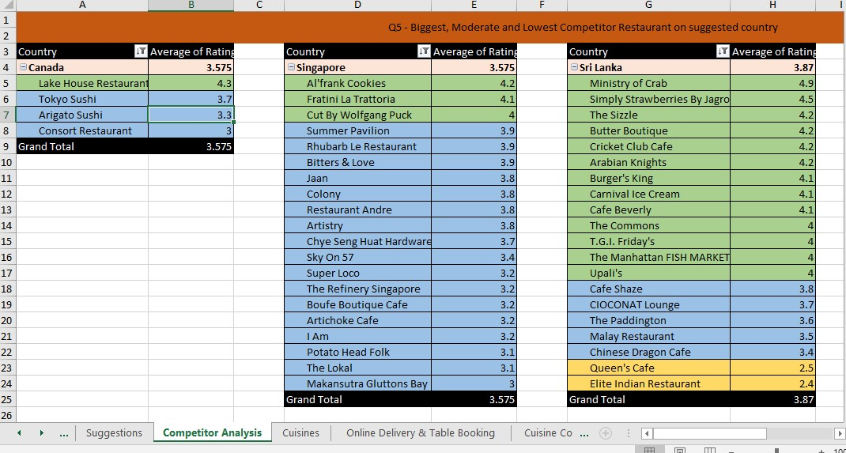

6. Which cuisines should we focus on in the newer restaurants to get better feedback? Does the choice of cuisines affect the restaurant ratings?

**Answer -**

**Our strategic culinary focus encompasses a diverse range of cuisines: Pizza, Mediterranean, Australian, Italian, Chinese, Bakery, Seafood, American, Continental, Desserts, and Beverages.**

* **These choices are informed by a meticulous analysis using pivot tables, ensuring a menu that resonates both locally and globally.**
* **Impact on Ratings:**
* **Culinary decisions wield significant influence on ratings. We’ve conducted a two-step analysis:**
* **The first pivot table dissects country-specific restaurant ratings, guiding us in adapting to local preferences.**
* **Simultaneously, the second pivot table provides a broader global perspective, emphasizing the pivotal role of culinary choices in shaping overall customer satisfaction.**
* **Rationale for Recommendations:**
* **Our cuisine selection is rooted in data insights from pivot tables.**
* **Average ratings inform the inclusion of cuisines aligned with local tastes.**
* **Globally acclaimed choices, such as seafood and Italian cuisine, enhance the overall appeal.**
* **Decision-Making Insights:**

**Detailed scrutiny of the first pivot table reveals trends, with seafood notably standing out in certain countries.**

**This serves as a decision-making foundation, emphasizing the critical influence of culinary choices on ratings.**

**The second pivot table further validates these insights globally, guiding informed adjustments based on customer feedback.**

* **Strategic Adjustments:**

**Leveraging insights from pivot tables, our goal is to make strategic adjustments that align offerings with local preferences and global trends.**

**This ensures the restaurant’s continued competitiveness, delivering an exceptional dining experience tailored to our diverse clientele.**

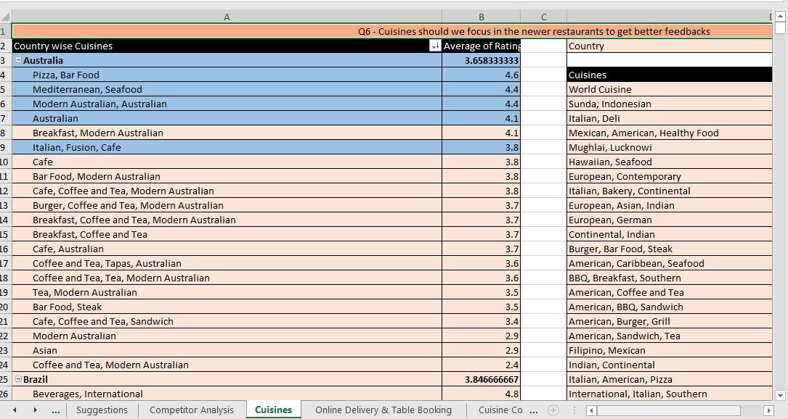

7. According to our current data, should we go for online delivery and table booking? Does that affect the customer’s ratings?

**Answer -**

* **Data Exploration Approach:**
* **I utilized two Pivot tables to assess the potential for table bookings and online deliveries across all countries.**
* **The analysis was based on average ratings, with online booking and table booking as row values.**
* **Strategic Recommendation:**
* **Considering that none of the existing restaurants currently offer these conveniences, it is advisable to implement table booking and online delivery services.**
* **This strategic move could provide us with a competitive edge.**
* **However, before proceeding, conducting a survey in the respective countries to gauge consumer interest and willingness toward online delivery and table booking would be prudent.**

**Reference - In the Excel sheet named “Online Delivery & Table Booking”**

**the table that suggesting According to current data, customer’s ratings for online delivery and table booking customer’s ratings.**

8. Should the team keep the rate of cuisines higher? Will that affect the feedback? According to our data are the rates of cuisines and ratings, correlated?

**Answer –**

**Direction:**

* + **The positive sign indicates a “Strong” positive correlation.**
  + **This implies that as restaurant ratings increase, there is a significant tendency for the average cost for two to also increase, and vice versa.**

**Magnitude and Significance:**

* + **It’s essential to recognize that the correlation is noteworthy, given its magnitude.**
  + **Therefore, the correlation analysis reveals a substantial relationship between ratings and average cost.**

**Decision:**

* + **Given this positive correlation, it is advisable to strategically adjust costs based on cuisine preferences and consider attractive offers to enhance customer engagement, leveraging this significant correlation.**

**Reference: In the Excel sheet named “Cuisine Cost and Correlation,” refer to the pivot table suggesting the cuisine relation with price and the rating relation with cost.**

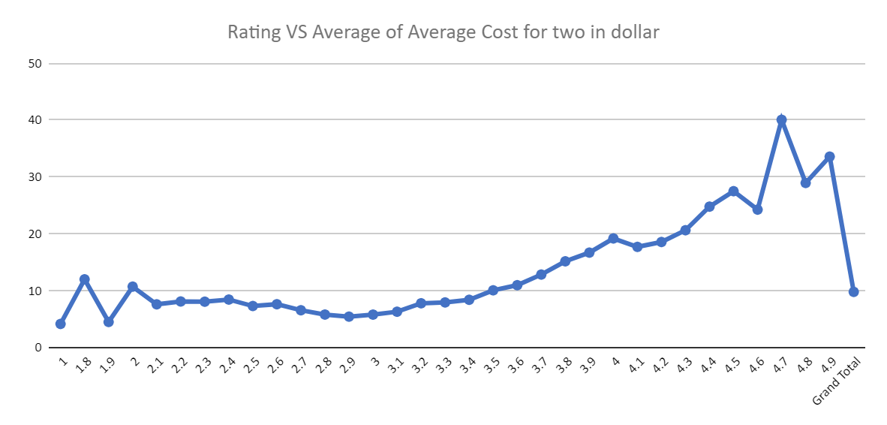

9. What is the distribution of the number of restaurants of different price ranges in all the countries?

**Answer – The distribution of the number of restaurants of different price ranges in all the countries are as follows.**

**Insights:**

* **This suggests a concentration of dining options in the more affordable price brackets.**

**Visualization:**

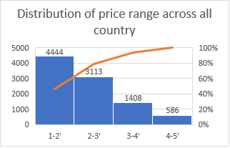

10. Explain your approach in brief for suggesting countries/cities in order to open new restaurants, if the objective and subjective questions would have been given to assist you. [you have to give bullet pointers in order to answer this question]

**Answer –**

**Identify Low Competition Areas:**

* **Filter the data to identify countries and cities with fewer existing restaurants, indicating lower competition in the market.**

**Strategic Recommendations:**

* **Based on the analysis, recommend countries and cities where the competition is low and average ratings are below a certain threshold (e.g., 4 stars). These areas present opportunities for new restaurant ventures.**

**Visual Representation:**

* **Use visualizations such as pivot charts, line graphs, and histograms to present the findings effectively and justify the recommendations.**

**Financial Considerations:**

* **Evaluate the current expenditure on food in the suggested countries to ensure financial viability and control over expenses.**

**Competitor Analysis:**

* **Identify the biggest competitors and low-rated restaurants in the recommended areas to understand the market landscape and potential challenges.**

**Correlation Analysis:**

* **Explore the relationship between restaurant ratings, cuisine prices, and other factors to make informed decisions regarding pricing strategies and menu offerings**